Tenant Credit Risk Dashboard (Snowflake | Python | Power BI)

Objective
To design an end-to-end data analytics solution that models, predicts, and visualizes tenant-level credit performance using modern data tools.
The project simulates real-world financial analytics use case — from raw data to insights — integrating Snowflake, Python, and Power BI.

Tools & Technologies
Category | Tools Used
Data Warehouse | Snowflake
Programming & Modeling | Python (Pandas, Scikit-learn)
Visualization | Power BI
Query Language | SQL
Data Integration | Snowflake Connector for Python

Workflow Overview
- Data Generation: Created synthetic datasets for tenants, payments, and properties using Python.
- Data Modeling in Snowflake: Designed tables, relationships, and a KPI View (TENANT_KPI_SUMMARY).
- Machine Learning: Built a Random Forest model to classify tenants into High Risk and Low Risk.
- Visualization: Developed an interactive Power BI dashboard showing rent collection, delay behavior, and coverage ratios.

Key Insights
- Identified tenants with chronic payment delays and low liquidity coverage.
- Segmented industries by rent performance and delay patterns.
- Created a scalable analytical model replicable for real-world credit monitoring.

Dashboard Highlights
- KPI Cards: Avg Rent %, Payment Delay, Coverage Ratio, High-Risk %.
- Visuals:
  - Top delayed tenants (Bar Chart)
  - Rent collection by industry (Bar Chart)
  - Risk segmentation (Pie)
  - Cashflow vs Delay (Scatter)
- Filters: Industry & Risk Level
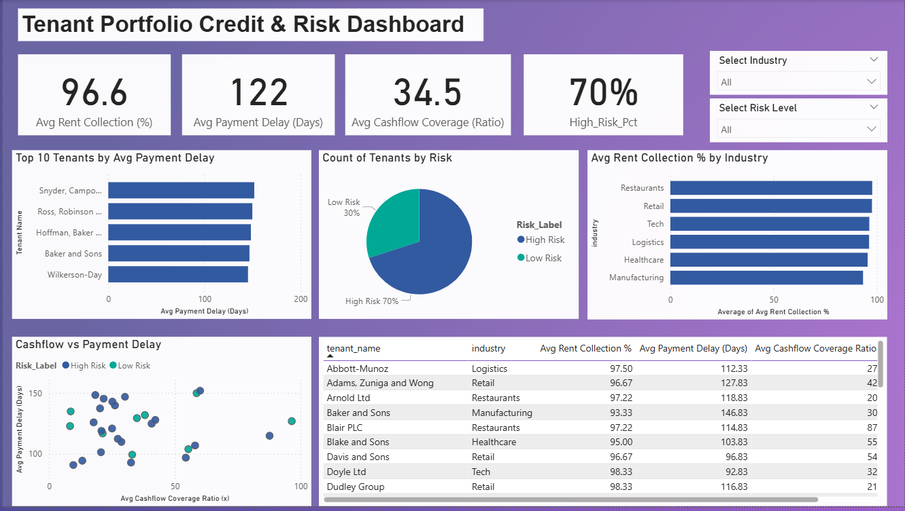

Outcome
An integrated data pipeline demonstrating skills across:
- ETL + Data Warehousing (Snowflake)
- Data Science (Python, ML)
- BI Visualization (Power BI)
This project showcases how data-driven finance analytics can anticipate credit risk and improve portfolio governance.

